REQUIRED INPUTS

1. Body Height (cm)


What it is
Your full body height from floor to top of head.

Why it matters
Used as:
- Secondary correction factor in reach & drop calculations
- Geometry validation check
- Frame size estimation

How to measure
- Stand barefoot against a wall.
- Heels, glutes, and upper back touching the wall.
- Look straight ahead.
- Place a book flat on your head against the wall.
- Mark the wall and measure from floor to mark.

Common mistakes
- Wearing shoes
- Tilting head upward
- Measuring alone without wall reference

2. Inseam Length (cm)
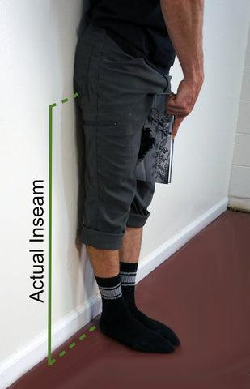
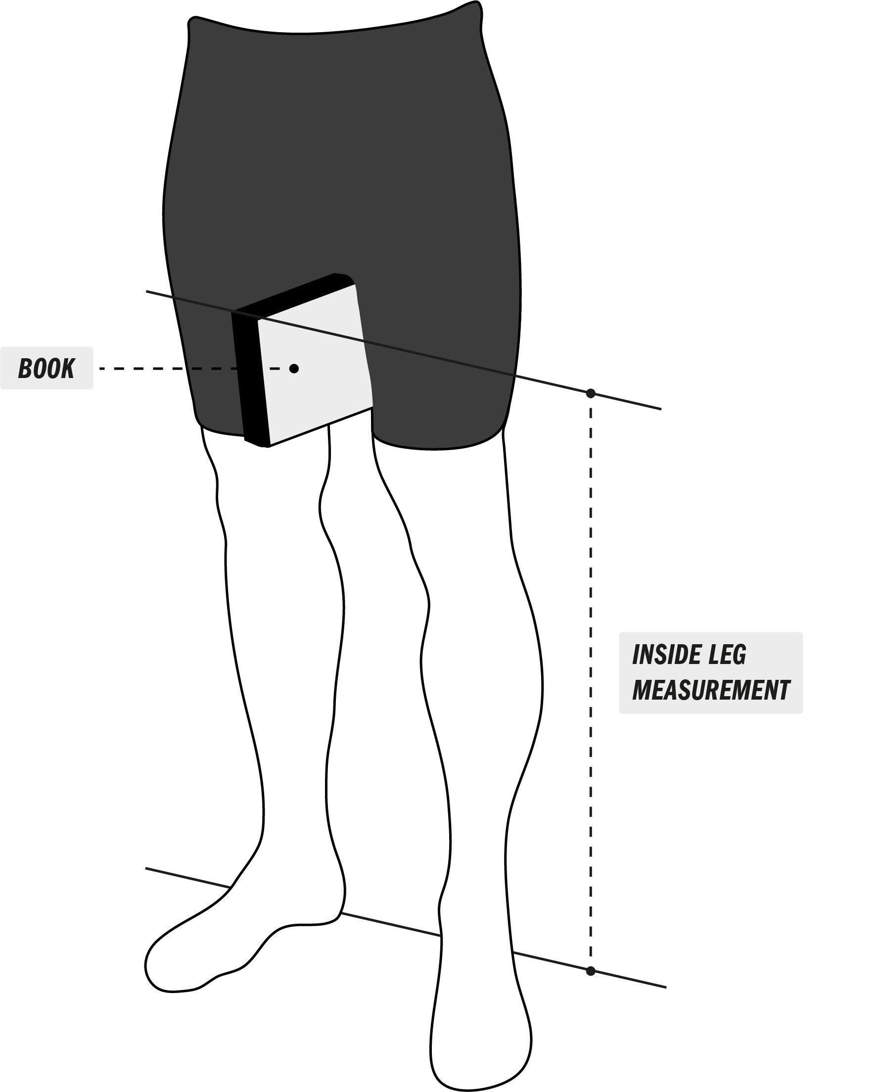
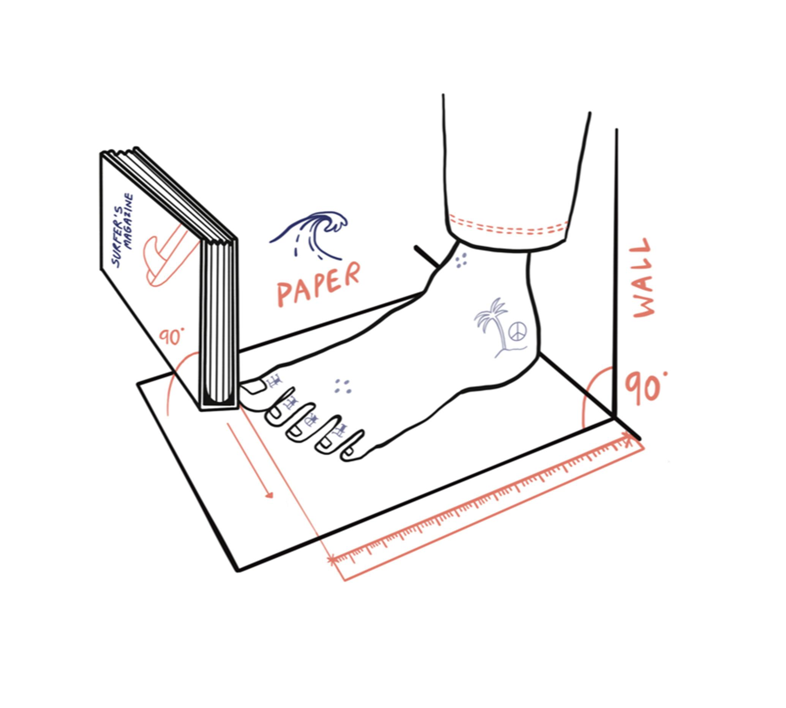
4

What it is
Distance from floor to pubic bone.

Why it matters
Primary driver of:
- Saddle height
- Crank length
- Setback starting point

How to measure
- Stand barefoot against wall.
- Place a hardcover book firmly between legs (simulate saddle pressure).
- Keep book horizontal.
- Measure floor to top edge of book.

Common mistakes
- Not applying upward pressure
- Using soft object instead of book
- Measuring with cycling shorts padding compressing

3. Riding Type
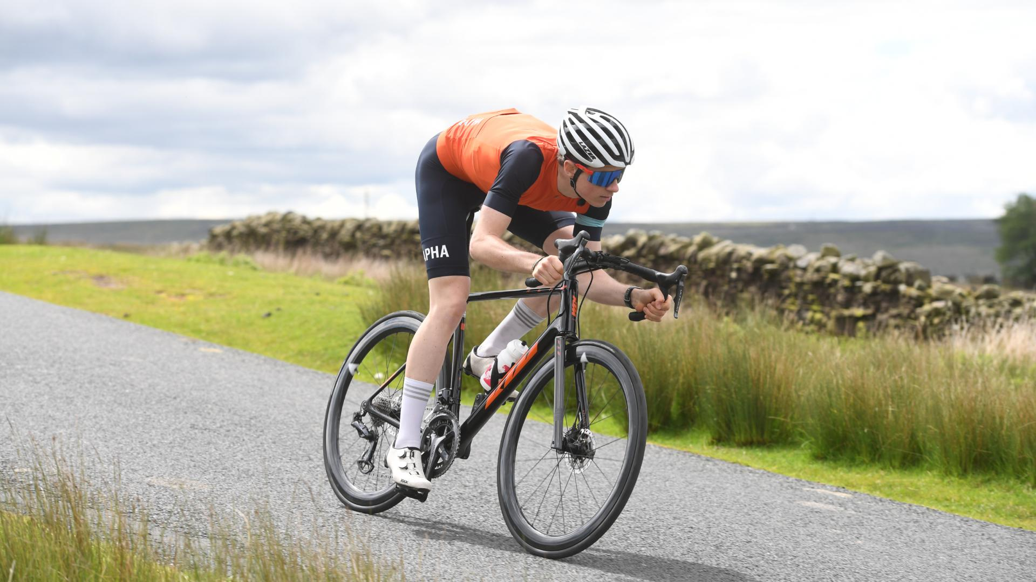
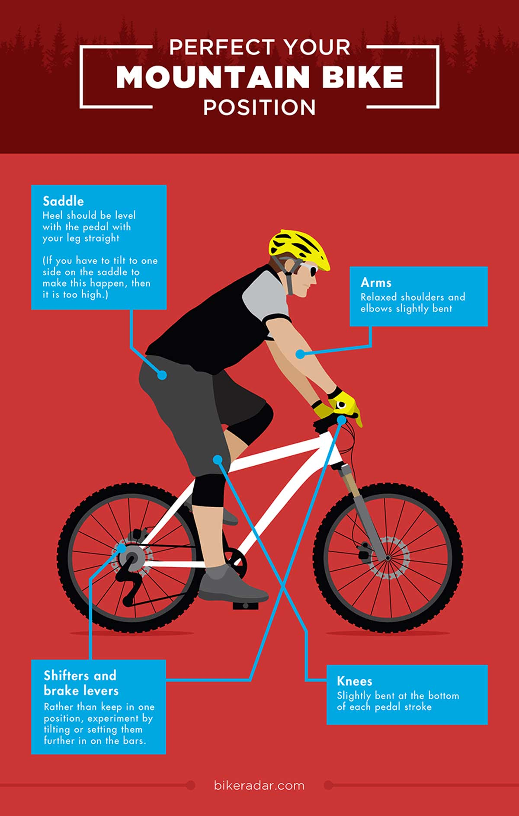
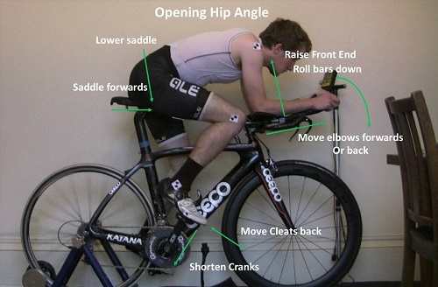
4

Options
- MTB Trail
- Road Endurance
- Road Race
- Time Trial (TT)

Why it matters
This changes:
- Reach
- Drop
- Setback
- Saddle height coefficient
Example:
- MTB = upright, less drop
- TT = aggressive, more drop

4. Flexibility Score (1–5)
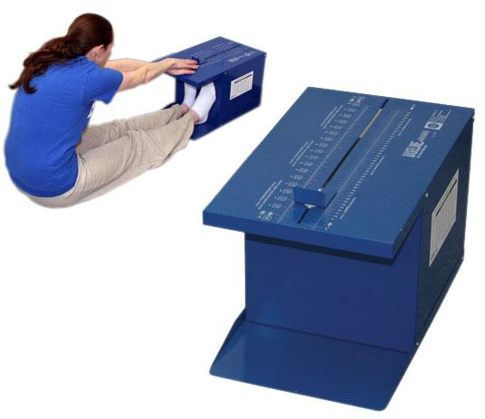
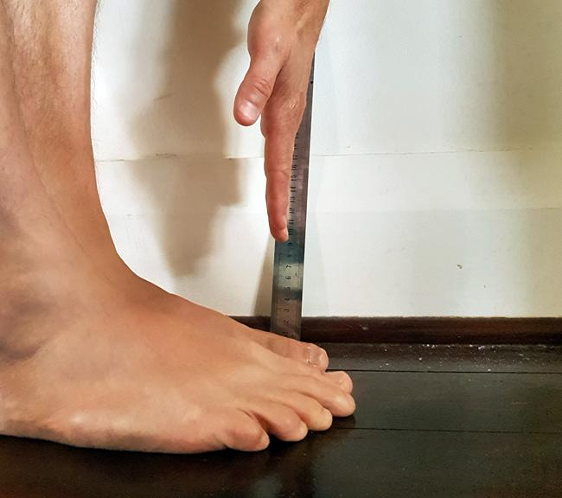
4

What it is
Self-assessed hamstring/lower back mobility.

Quick self-test
Sit on floor with legs straight:
- Cannot reach knees → 1
- Reach mid-shin → 2
- Reach ankles → 3
- Reach toes → 4
- Hands past toes → 5

Why it matters
Controls:
- Handlebar drop
- Aggressive reach limits

5. Core Stability Score (1–5)
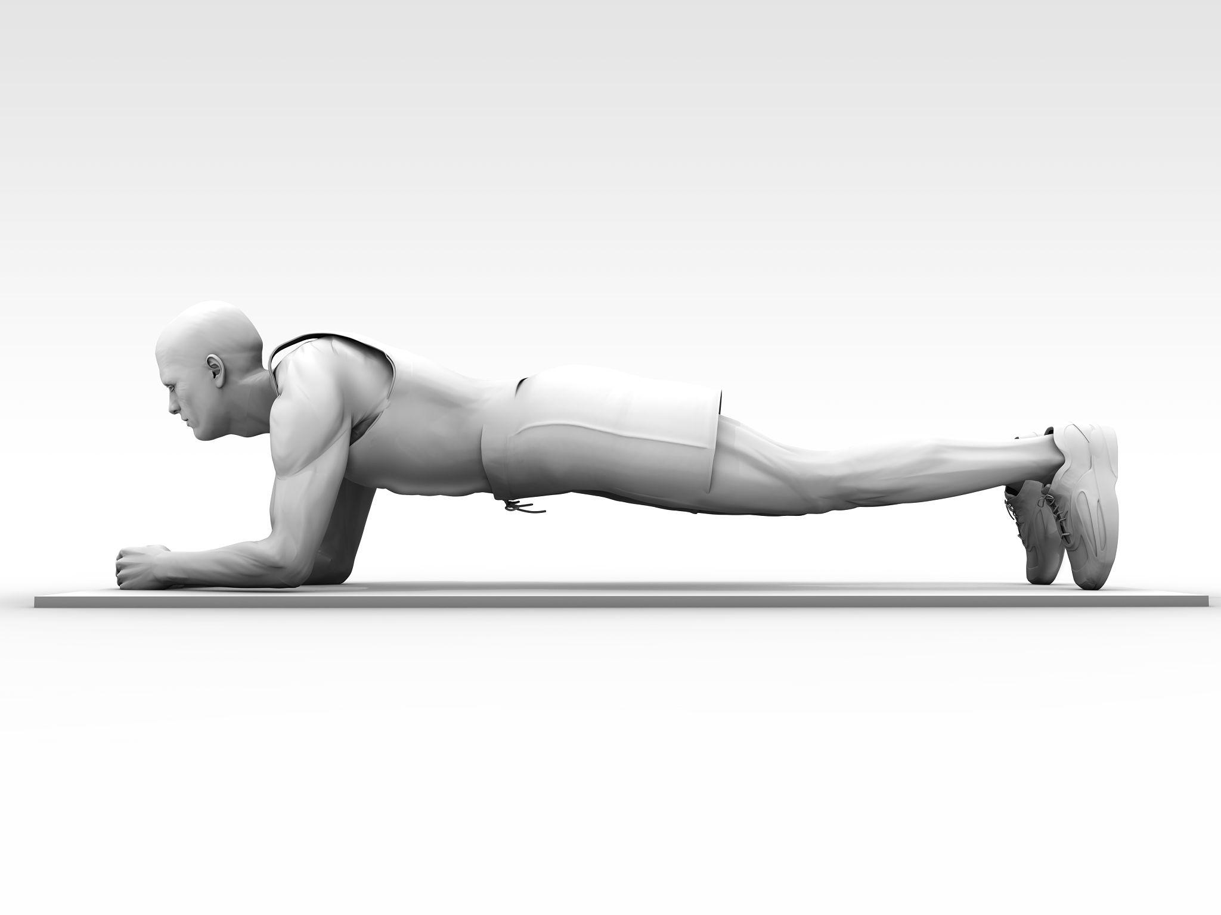
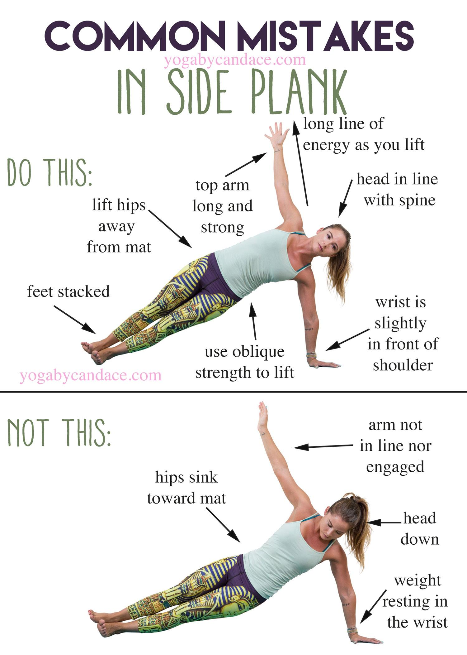
4

What it is
Ability to hold stable pelvic position.

Test
Standard plank:
- <20 sec → 1
- 30 sec → 2
- 60 sec → 3
- 90 sec → 4
- 120+ sec perfect form → 5

Why it matters
Impacts:
- Allowed reach
- Drop tolerance
- Saddle stability recommendations

OPTIONAL (ADVANCED INPUTS)

6. Torso Length (cm)
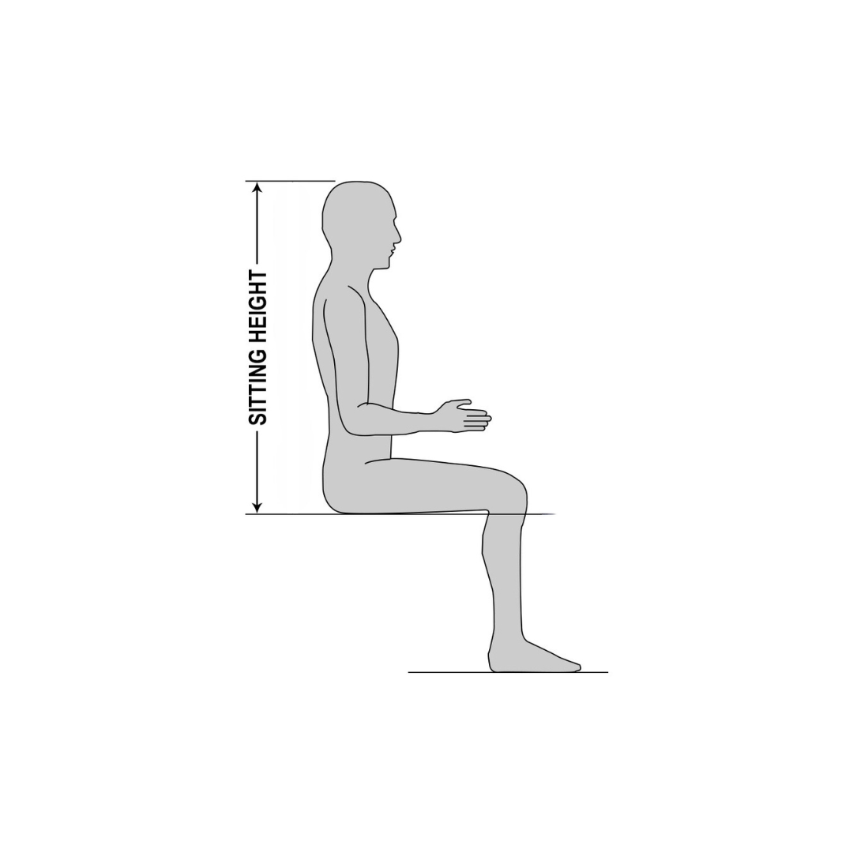
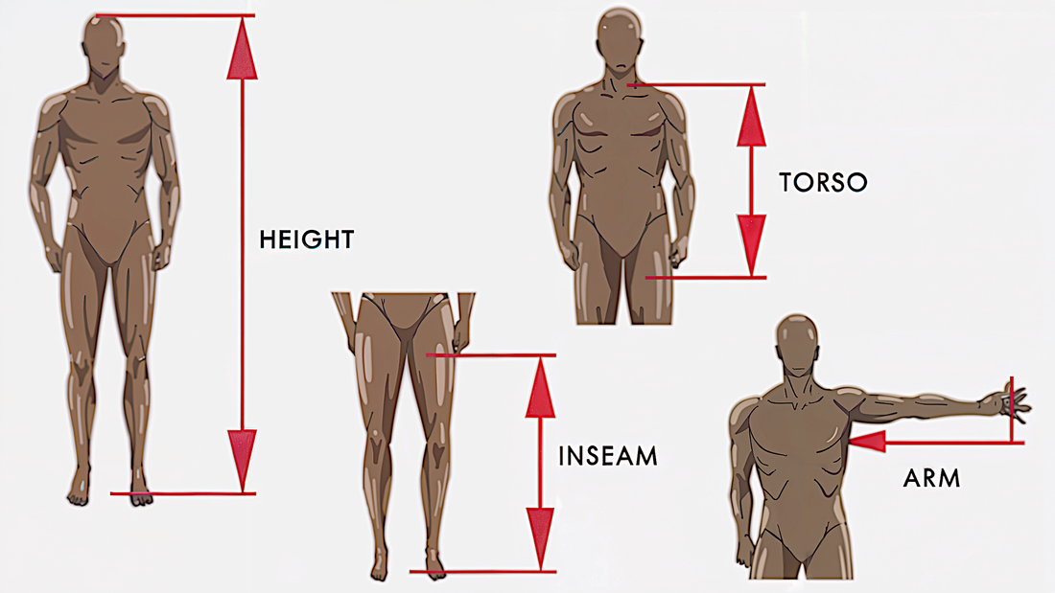
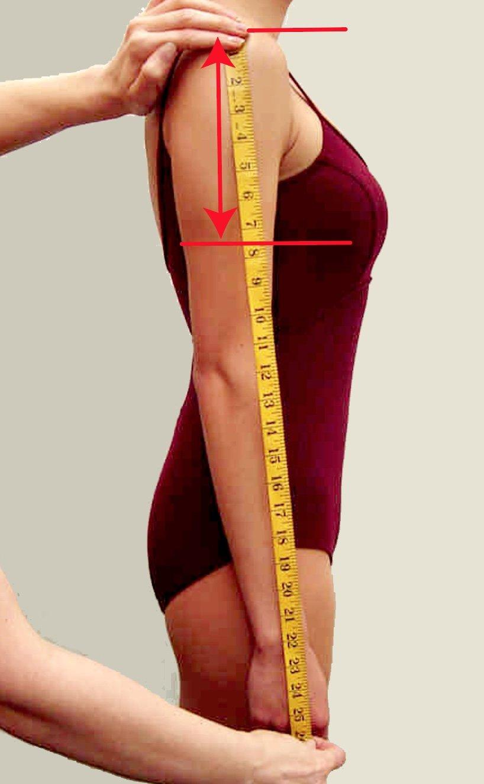
4

What it is
Hip joint to shoulder joint distance.

Why it matters
Major determinant of cockpit reach.

How to measure
- Sit upright against wall.
- Measure from top of hip bone (iliac crest) to top of shoulder (acromion).

7. Arm Length (cm)
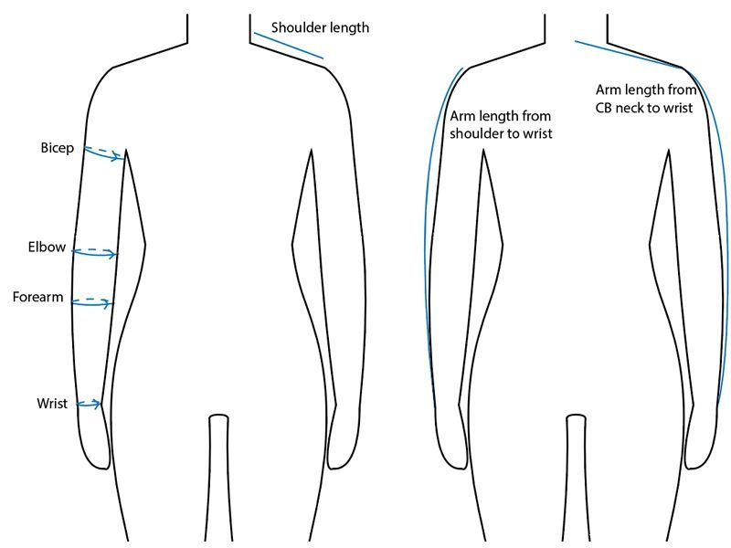
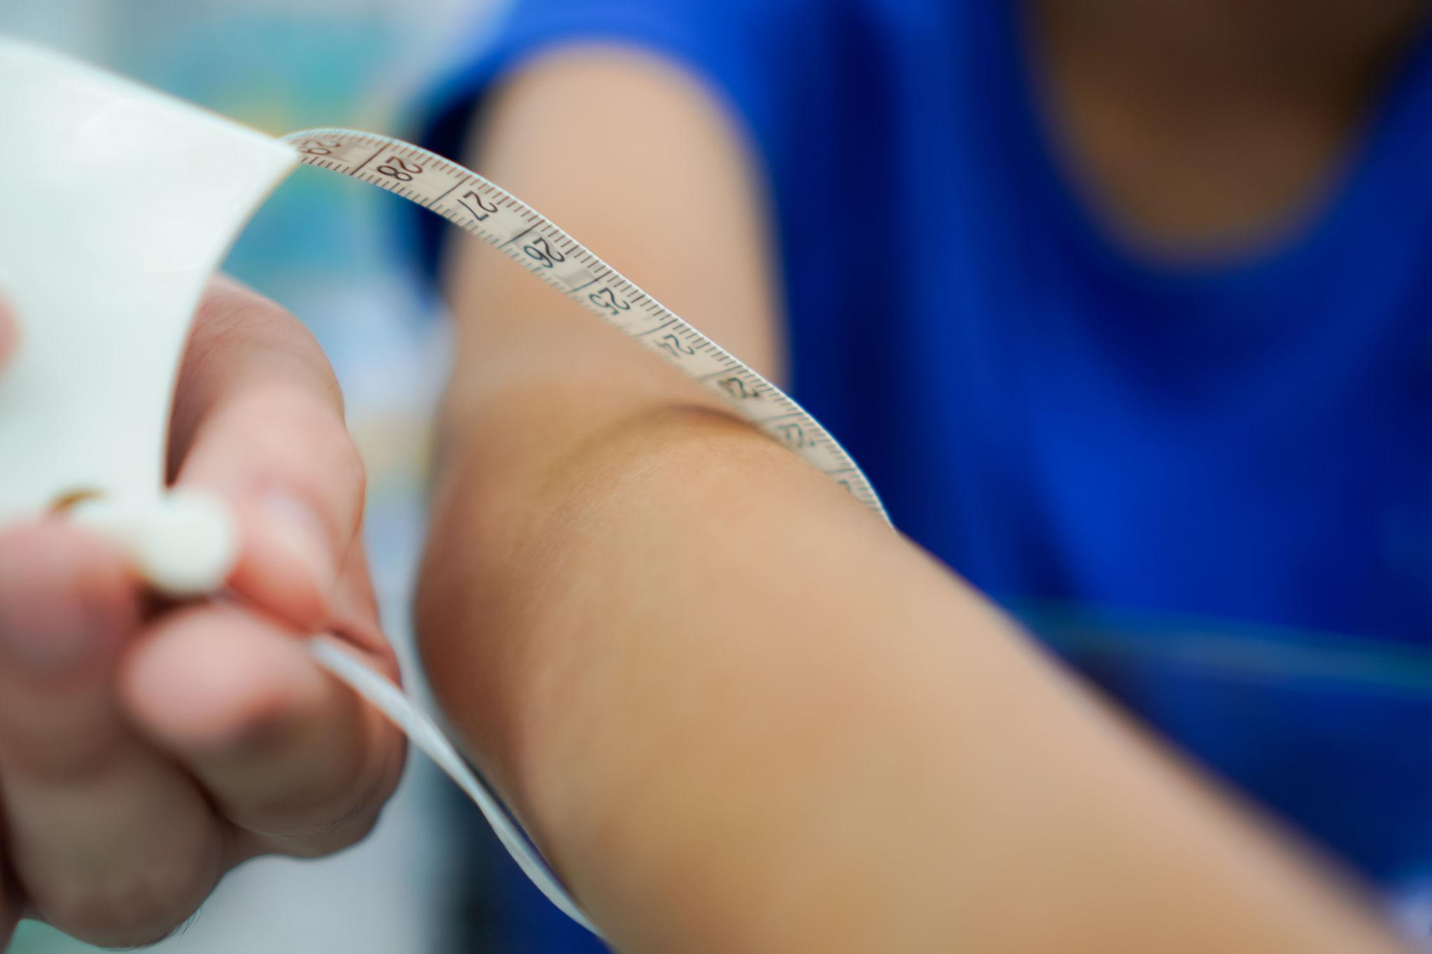
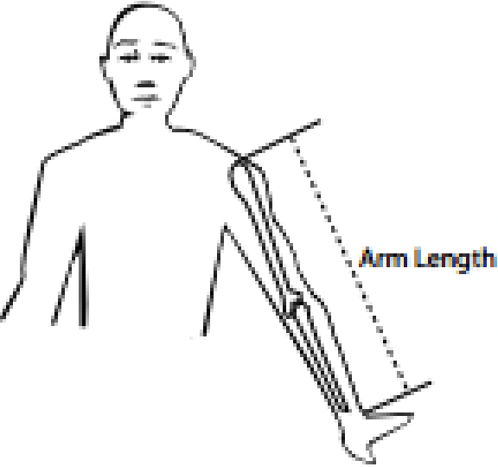
4

What it is
Shoulder joint to wrist joint.

Why it matters
Affects reach and handlebar position.

How to measure
Arm extended slightly forward:
Measure from shoulder bone to wrist crease.

8. Femur Length (cm)
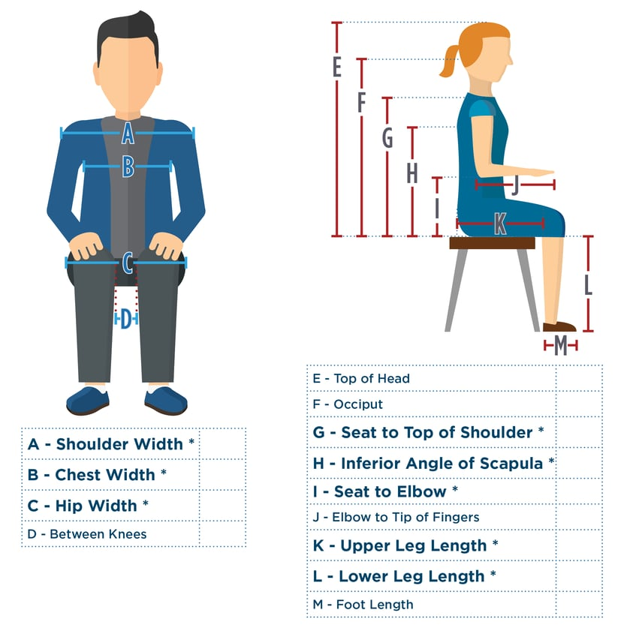
4

What it is
Hip joint to knee center.

Why it matters
Strong driver of saddle setback.

How to measure
Seated:
Measure from greater trochanter (side hip bone) to center of kneecap.

9. Shoulder Width (cm)
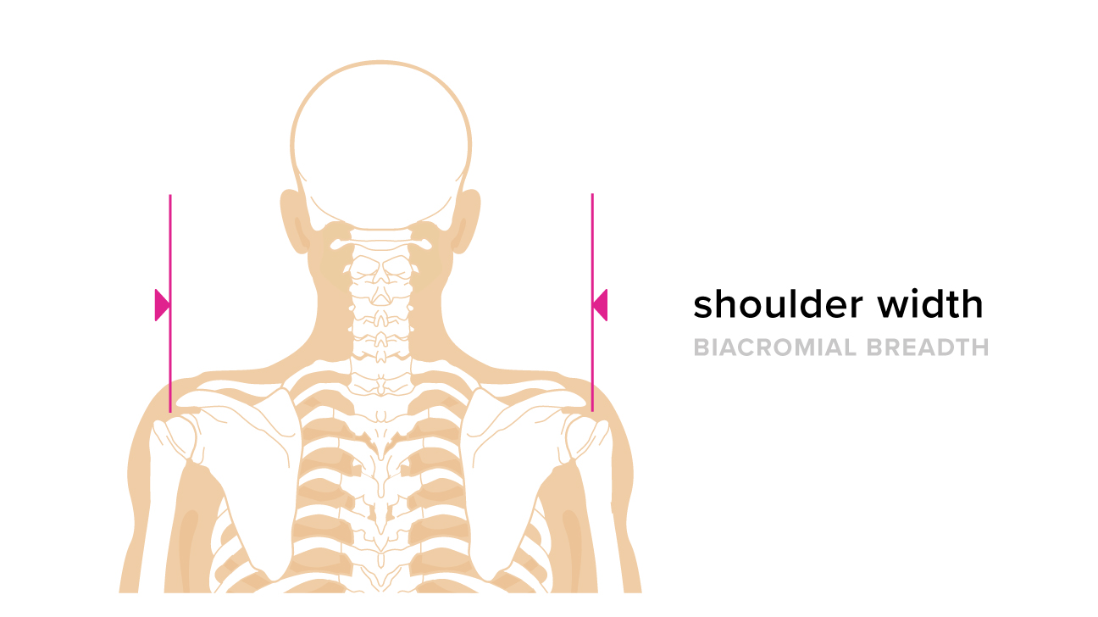
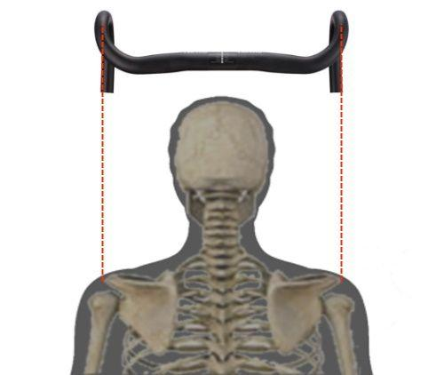
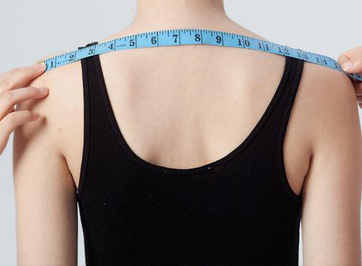
4

What it is
Distance between acromion bones.

Why it matters
Determines:
- Road bar width
- MTB bar width scaling

How to measure
Measure back side from outer shoulder bone to shoulder bone.

10. Foot Length (mm)
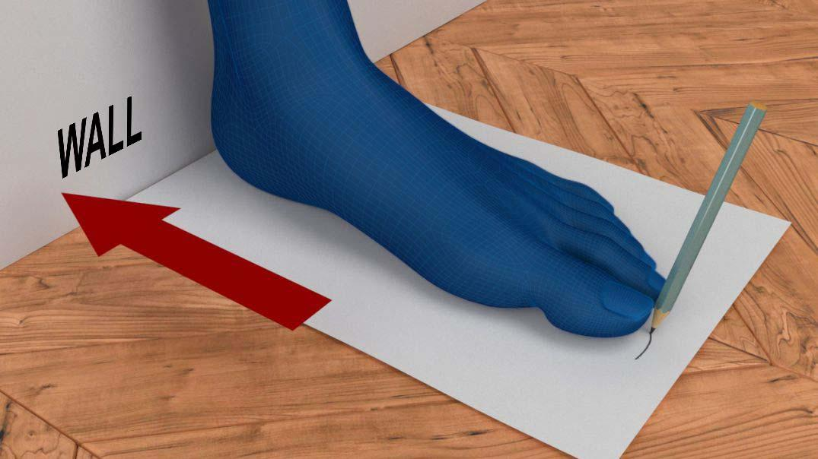
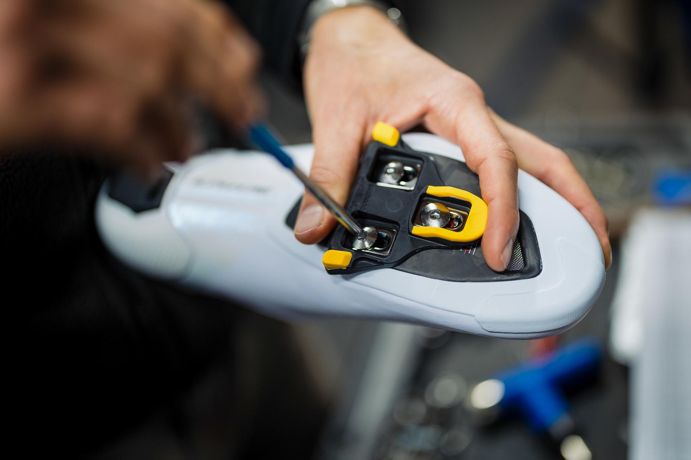
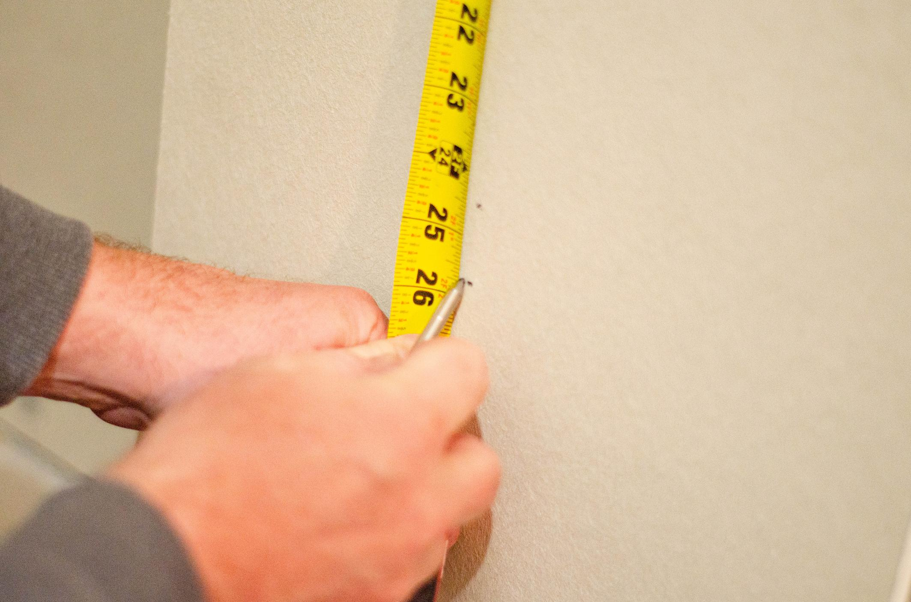
4

What it is
Heel to longest toe.

Why it matters
Used for:
- Cleat fore-aft positioning
- Power transfer optimization

How to measure
Heel against wall.
Measure to longest toe.

11. Current Setup (Optional but recommended)
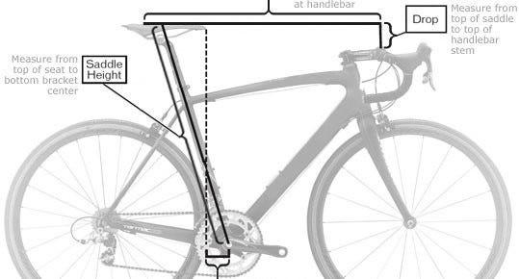
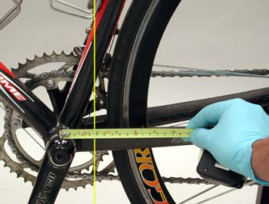
4

Fields
- Current saddle height
- Current setback
- Current drop
- Stem length
- Crank length

Why it matters
Allows:
- Delta comparison
- Progressive adjustment plan
- Risk reduction

Measurement Accuracy Rules for the App
To avoid garbage-in/garbage-out:
- Force cm or mm consistency
- Reject inseam > 55% of height
- Reject torso + inseam > height + 5 cm
- Flag unrealistic crank suggestions

